Plant Research & Data Model
Research fields, data quality, model evolution and mapping to the implemented Plant domain object
Evolution: Week 5-7 research model -> Week 9 implemented data model

1. Purpose and Scope
This document defines the plant information model used by Plantopedia and records how the original Week 5-7 research design evolved during implementation. The early model focused on descriptive, growing and safety information. By Week 9, the team had integrated an SQLite dataset with a more structured taxonomic model. The current implementation therefore aligns the Java Plant object and the PlantsData table with the fields available in that dataset while retaining earlier ideas as future refinements.

2. Design Evolution
Stage | Design focus | Outcome
Week 5-7 initial research model | Common/scientific name, description, habitat, distribution, growing requirements and safety information. | Useful research framework and candidate MVP fields.
Dataset/database integration | Existing PlantsDB.db and PlantsData schema introduced structured taxonomy and state/province data. | Plant model revised to align with the persisted dataset.
Week 9 implementation | Java Plant fields and SQLite columns aligned; DAO persistence and tests implemented. | Current application model supports reliable CRUD, retrieval, search and pagination.

3. Implemented Plant Research Record
Category | Java field | SQLite column | Type | Purpose
Identification | id | PlantID | Integer | Database-generated unique plant identifier.
Description | generalisedInfo | Generalised_info | Text | General descriptive information about the plant.
Media | images | images | Text | Image reference or image-related data used by the application.
Distribution | stateProvince | stateProvince | Text | State/province or geographic occurrence information.
Taxonomy | scientificName | scientificName | Text | Scientific/botanical name.
Taxonomy | kingdom | kingdom | Text | Taxonomic kingdom.
Taxonomy | phylum | phylum | Text | Taxonomic phylum.
Taxonomy | pclass | class | Text | Taxonomic class. Java uses pclass because class is a Java keyword.
Taxonomy | order | order | Text | Taxonomic order.
Taxonomy | family | family | Text | Taxonomic family.
Taxonomy | genus | genus | Text | Taxonomic genus.
Taxonomy | taxonRank | taxonRank | Text | Taxonomic rank supplied by the dataset.
Identification | vernacularName | vernacularName | Text | Common or vernacular display/search name.
Taxonomy | species | species | Text | Species information.

4. Field Mapping Principle
The implemented model deliberately keeps the research data, Java domain object and persisted database record aligned. This reduces translation errors and makes DAO mapping explicit.
Research / dataset field
↓
Plant.java domain field
↓
SQLitePlantDAO mapping
↓
PlantsData column

5. Fields Deferred from the Earlier Model
The following fields appeared in the original research model but are not columns in the current PlantsData implementation. They should therefore be described as deferred or future enhancements rather than current persisted MVP fields.
Earlier field | Current status | Possible future treatment
plantType | Deferred | Add if required by filtering or display user stories.
habitat | Deferred | Add as a field or related ecological data structure.
sunlightRequirement | Deferred | Potential GrowingRequirements value object/field.
waterRequirement | Deferred | Potential GrowingRequirements value object/field.
toxicityStatus | Deferred | Potential PlantSafety field/value object.
safetyInformation | Deferred | Potential PlantSafety field/value object with source verification.
sourceName / sourceUrl / dateAccessed | Recommended future provenance | Normalise into a PlantSource relation if research traceability becomes a sprint requirement.

6. Research and Data Quality Workflow
Select candidate native plant
↓
Confirm identity and scientific name from a reliable source
↓
Capture available taxonomy and state/province information
↓
Record general information and image reference
↓
Check values against the implemented Plant field structure
↓
Peer review / validate the record
↓
Persist through SQLitePlantDAO

7. Suggested Data Quality Rules
- PlantID is the unique persisted identifier and should be generated by the database when a new plant is added.
- Scientific and vernacular names should be checked for accidental whitespace, spelling differences and inconsistent capitalisation.
- Taxonomic fields should be stored in the correct level: kingdom, phylum, class, order, family, genus and species.
- stateProvince should represent geographic occurrence consistently rather than mixing unrelated descriptive text.
- Image values should follow one agreed convention (for example resource path, file name or URL) so the UI can interpret them consistently.
- Future safety claims should be traceable to an authoritative source before being displayed as verified guidance.

8. Example Implemented Record Structure
Field | Example value
vernacularName | Bird's Nest Fern
scientificName | Example scientific name
stateProvince | Queensland, Australia
kingdom | Plantae
phylum | Tracheophyta
pclass | Polypodiopsida
order | Polypodiales
family | Example family
genus | Example genus
taxonRank | species
generalisedInfo | General descriptive information for display in the encyclopedia.
images | Application image reference

9. Evidence of Iteration
The difference between the early research model and the implemented Week 9 model is intentional evidence of iteration. The team began with a broad encyclopedia-oriented field set, then refined the model after integrating the actual plant dataset and SQLite schema. Earlier growing, safety and provenance ideas remain documented as future extensions rather than being incorrectly represented as implemented functionality.
The Plantopedia domain and persistence design evolved throughout development rather than remaining fixed from the initial design stage. Early modelling used a broad encyclopedia-oriented Plant research model containing proposed attributes for plant identification, growing requirements, safety and descriptive information. As the team integrated the actual plant dataset and PlantsDB.db SQLite schema, the implemented Plant domain model was refined to align with the fields available in the persistent dataset. Earlier proposed fields that were not supported by the implemented dataset were retained as possible future extensions rather than being represented as completed functionality.
The persistence architecture also evolved incrementally. Initial development used MockPlantDAO to support application development using in-memory Plant objects behind the IPlantDAO abstraction. The persistence iteration introduced SQLitePlantDAO, which implements the same DAO abstraction using JDBC and the SQLite PlantsData table. This allowed persistent storage to be introduced without coupling database operations directly to the JavaFX presentation layer.
Automated testing evolved alongside the implementation. PlantTest verifies the behaviour and state of the Plant domain model, while SQLitePlantDAOTest verifies database persistence behaviour including CRUD operations, retrieval, search/pagination and edge cases. During integration, the persistence feature branch was updated against the team's evolving master branch, test conflicts were resolved, and the automated tests were rerun successfully before the updated branch was pushed for pull-request review.
Together, these changes provide evidence of iterative development across the domain model, persistence architecture, automated tests and team integration workflow.

Development stage | Earlier approach | Current implementation | Evidence
Plant model | Broad proposed research/encyclopedia fields | Model aligned with actual persistent plant dataset | Plant.java, PlantTest.java
Data access | In-memory/mock persistence | JDBC/SQLite persistent implementation | IPlantDAO, MockPlantDAO, SQLitePlantDAO
Testing | Initial model/DAO testing | Expanded domain and SQLite persistence test coverage | PlantTest, SQLitePlantDAOTest
Integration | Feature developed independently | Updated against current team master and conflicts resolved | Git commit history and PR #72
Verification | Individual implementation testing | Tests rerun after integration | Successful IntelliJ/JUnit test results

10. Selected Plant Model Test Evidence
The implemented research model is supported by unit tests for the Plant domain object. These tests are useful here because they demonstrate that the Java model can retain and expose the same field values that are mapped into the persistence layer. Full test classes remain in the source repository; only representative evidence is included in this design document.

Snippet 1 - Representative Plant domain field verification
// Representative PlantTest pattern
Plant plant = new Plant();
plant.setScientificName("Example scientific name");
plant.setVernacularName("Example common name");
assertEquals("Example scientific name", plant.getScientificName());
assertEquals("Example common name", plant.getVernacularName());

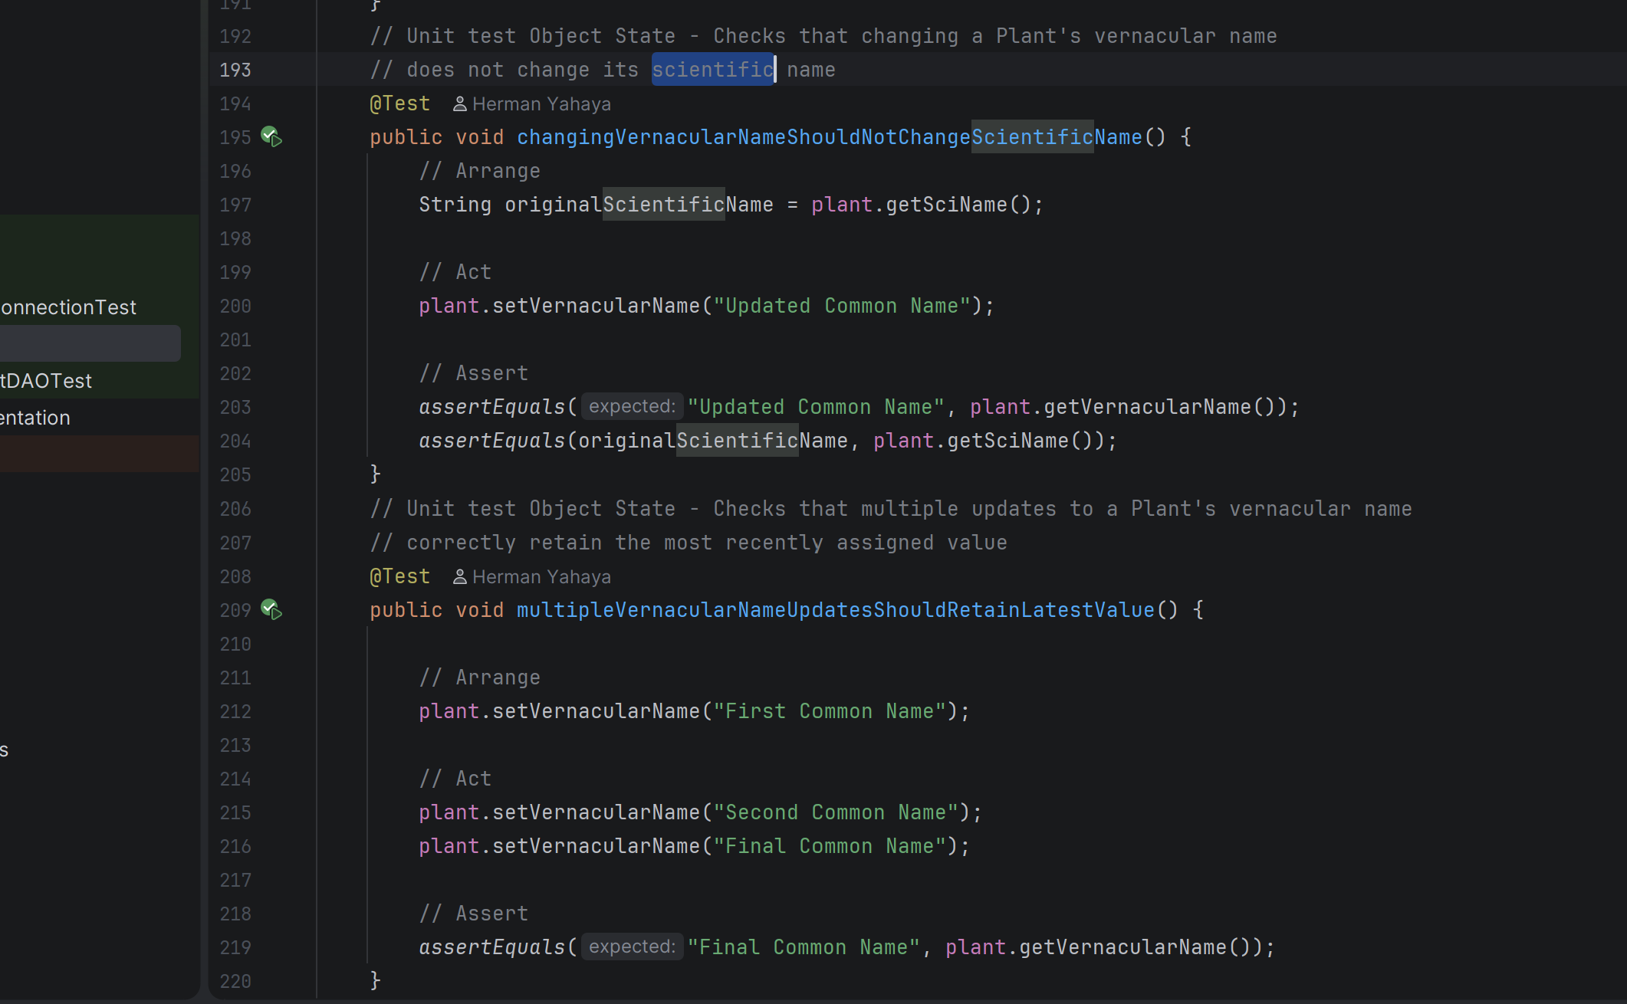

This representative pattern corresponds to the purpose of PlantTest: verifying model field values, getters/setters and object state. The actual repository tests also include edge-case/object-state coverage. The snippet is intentionally concise so the document explains the model rather than reproducing the complete test suite.
Implementation note: PlantTest and SQLitePlantDAOTest passed together after the feature branch was brought up to date with master, providing current evidence that the evolved model and persistence mapping remained compatible.

